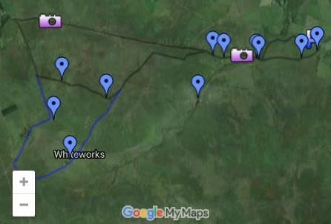
Along the Swincombe and the Dartmoor Way

View Larger Map

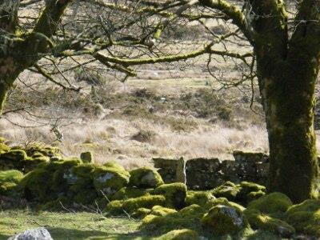

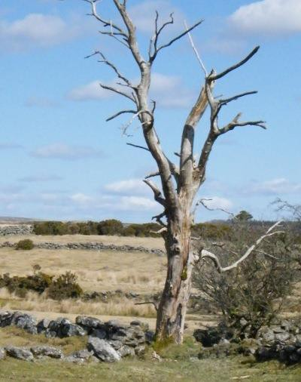
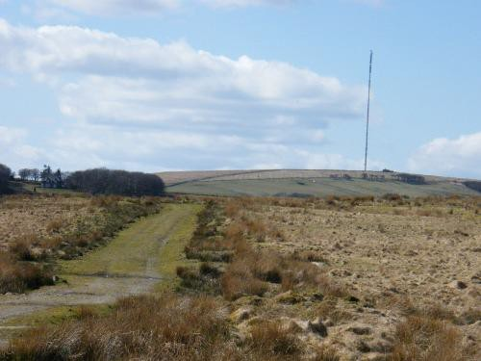
View West along Dartmoor way to North Hessary Tor

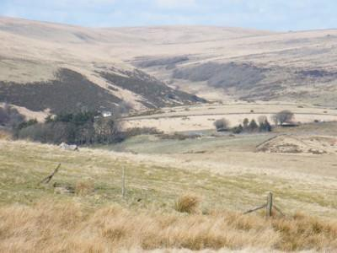
View Northward to Wistman's Wood

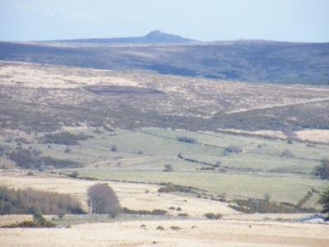
View East

These walks are all circular, starting in a car park, making them very convenient for locals and visitors alike. They have all been walked by the editor of this site in the company of his wife and a German Sheepherd Dog. The dog can get over all the obstacles whitout assistance so, on that basis, I consider them 'dog friendly'. Generally I try to minimise road walking, prefering lanes and public footpaths. Paths are often muddy and hills steep so prepare accordingly. I hope you enjoy your walks and don't leave any gates open.

A circular walk from the free car park in Loddiswell to Idston then on to Alleron and back
- Exit the car park via foot path at the far end
- Cross the main road
- Bear left and then right onto path before stile cottage
- Carry on up the steps, across the road in Elmwood Park until the stile onto Clarks Barn Road
- Cross the road to the stile on the opposite side
- Follow the path through two gates
- After the last gate the path goes across the field to a stile into the road
- Turn left and follow the road down the hill to the stream
- Over the bridge, up the steep hill, past Lower Idston on your right
- At Idston Farm take the bridal path on the right
- Follow the bridal path, along the lane and eventually open fields
- At Alleron exit through the gate on to the road
- Turn right on the road and follow it all the way back to Loddiswell Butts
- Enter the Playing Fields via the gate from the Butts
- Walk across the playing fields to the far side, through the gate into Elmwood Park
- Follow the short section of road to the main access road of the park and turn left toward the main road
- At the main road turn left, walk about 20 metres the cross the road and back into the car park

A circular walk from the free car park in Loddiswell to Hatch Bridge then on to New Mill and back
- Exit the car park via foot path at the far end
- Cross the main road
- Bear left and then right onto path before stile cottage
- Carry on up the steps, across the road in Elmwood Park until the stile onto Clarks Barn Road
- Turn left and follow the road South
- Keep walking, past the road junction on your left, to the next junction on your left (Towns Lane)
Alternate route
  - Turn left down Towns Lane
  - Where the road takes a sharp left, cross into the field via the stile on your right
  - Follow the public foot path through the fields to the lane
  - Turn left at the lane and carry on until Hatch Bridge
Primary route
  - Carry on along the same road, down the hill, until you get to a lane leading off to the left
  - Follow the lane all the way to Hatch Bridge. The alternate route rejoins this route on the lane, just before the bridge
- Cross the bridge and carry on along the road
- Just after the road junction you will see a stile on your left
- Go over the stile and follow the public footpath, over the foot bridge, to the Avon
- Carry along beside the river to the main road bridge
- Cross the main road via the steps and stiles
- Follow the path beside the river to the next stile
- Cross the stile and go straight ahead (do not turn left and cross the bridge) along the road
- Carry on until the road junction
- Turn left and cross the bridge
- Drop in at the Garden Centre Cafe if you feel like it!
- Walk up the very steep section of the hill and take the lane off to the right
- Bear left on up the hill after 8 metres
- Carry on up the lane to Ham Butts
- Turn left on the road and follow it down past the church into the village
- Walk past the Post Office on your right and right at the junction for the car park
A circular walk from Loddiswell to the Avon and back Loddiswell and the old Railway line
- Start at the Post Office (Yes! Loddiswell still has one.)
- Follow the road up beside the left side of the Church to Ham Butts
- Carry straight ahead on the road signposted for Reads Farm
- Right before the entrance to the farm take the public footpath, via a gateway on your right
- Follow the stream on your left, crossing one stile, down the valley to the Avon
- Towards the bottom of the hill you will need to cross the stream. There is a foot bridge and usually some mud too.
- The path now passes into a field. The river will be ahead of you. When you reach the river, turn left and head into the woods.
- The path is easy to follows upstream.
- Keep walking up the river until you get to the old railway bridge. Stop to admire the view.
- You now have a choice to make:
  - Short Walk - 2.5 miles
    - Take the path that heads off to the left, just before you reached the bridge. It heads up a lane toward the B3196.
    - About half the distance between the river and the road you will see a stile on your left. You can cross this and make your way back to Ham Butts via Ham Farm
    - If you carry on up the lane you will get to the B3196
    - Turn left and follow the road back to the Post Office in Loddiswell
  - Longer Walk 3.7 miles
    - Take the path along the old railway line heading upstream.
    - Carry on until the next bridge.
    - Cross it and turn right onto the path that heads back down the river
    - Walk down river iback to the first railway bridge,
    - Complete your walk by following the directions on the short walk option.

Aveton Gifford Tidal road and Bigbury

